Case Study 1.5: CGM quality with 2 x G6 overlapping V 2.1


Overlapping use of two G6 allows to switch AAPS to the
smoother performing sensor, as required for FCL

Often, in the first hours after starting a new G6 sensor, CGM values are quite instable, and may also come with systematic errors in excess of 50 mg/dl.

This screenshot shows:

Left side (G6 on left arm, ~ 9 d old w&/regular Tm)
shows smooth slight rise in last 4.2 hours :
Right side (G6 on right arm, w/Anubis) was started 4.2 hours ago, runs initially very much higher, much more un-steady, and overall in the opposite direction:
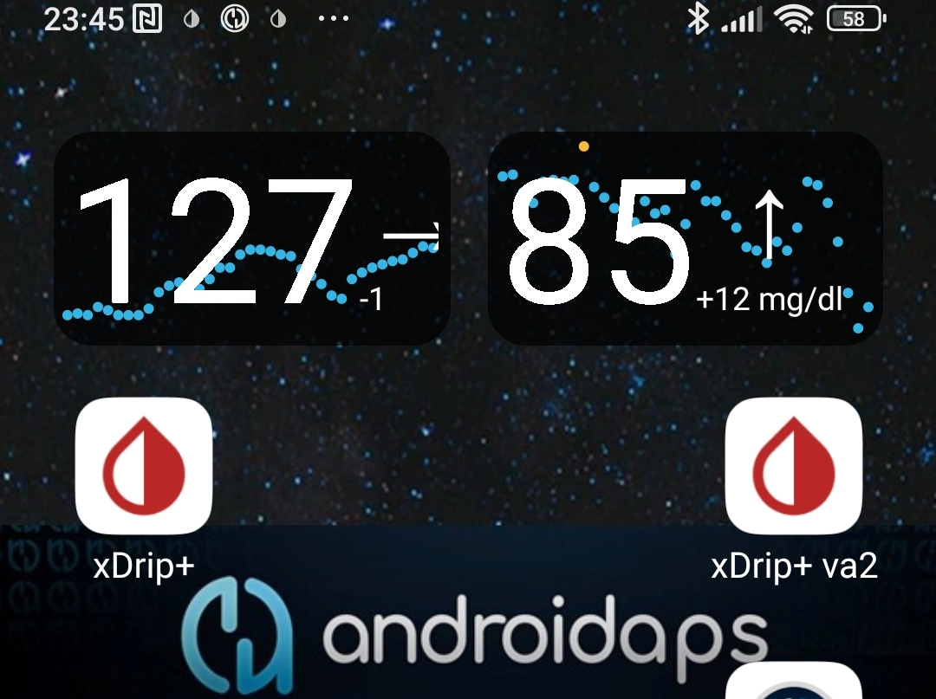
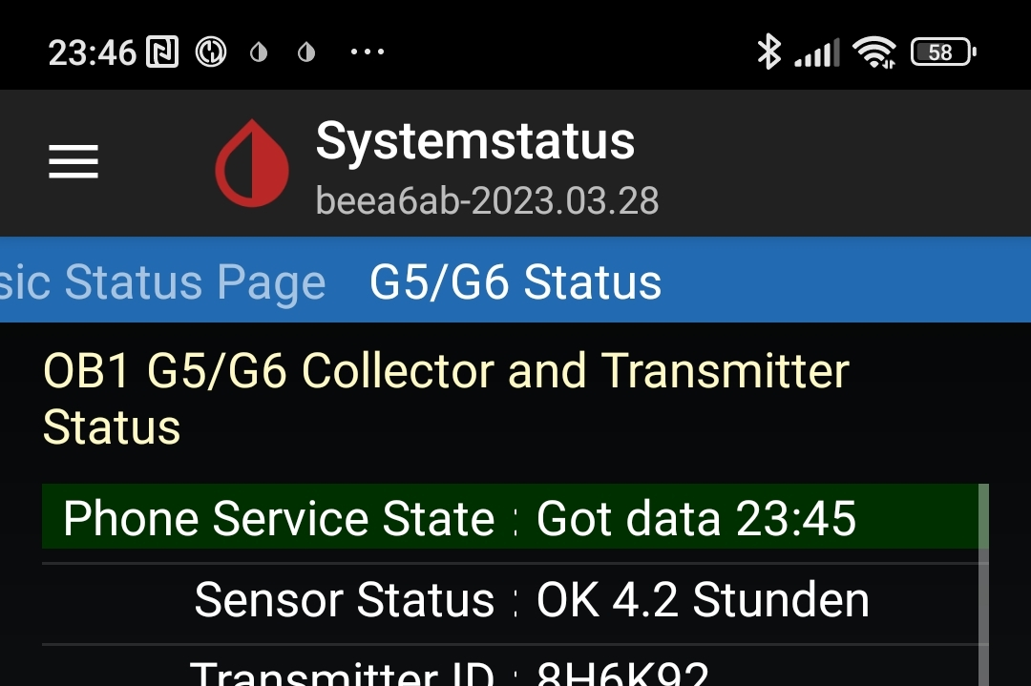
4.2 hours before 23:45

In the next 9 hours that followed (during the night), the new sensor smoothened, and was ready-for-use when, at 10.0 days, the left one literally dropped out:
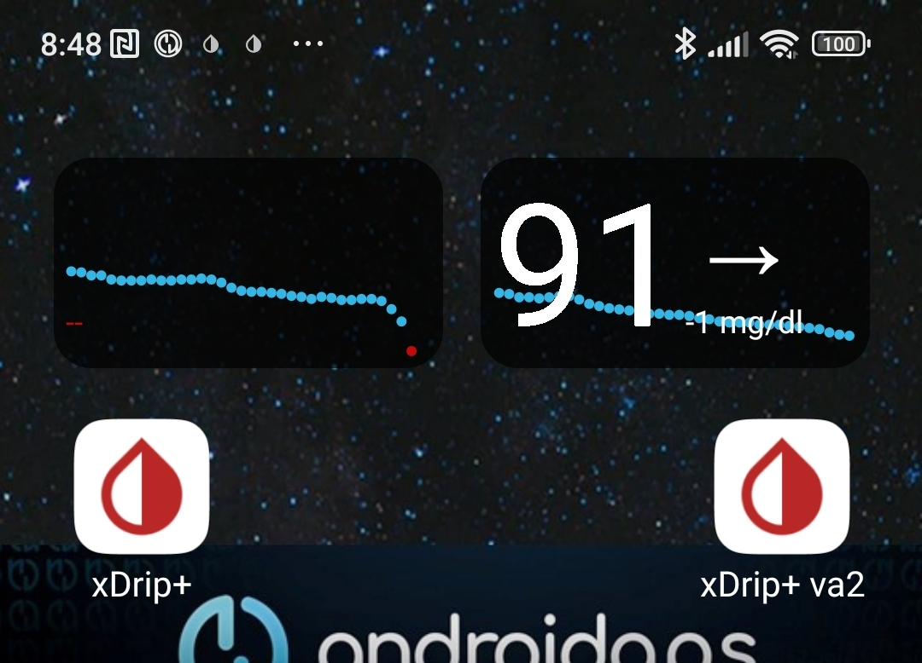

In the example shown, the new G6 on the right side arm looks good now. But it was clearly not useable for full closed looping in the first 5-6 hours after it had delivered first values ….

If you had no second, better performing, sensor to switch over to: Exit “autoISF adaptation of ISF to glucose behavior” until you see smooth CGM performance again!
Regarding open loop or HCL, you must decide whether setting different TT, different %profile, odd TT to disable SMBs, and maybe a calibration get you to a sufficiently safe and worthwhile bridging solution. (Note that each of the 4 just mentioned potential “solutions” would interfere with your autoISF FCL!)

…It performed nicely thereafter. This is why overlapping use of two G6 is a recommended CGM set-up for FCL.

Below is described, how an overlapping system can be set up.

Overlapping G6 (right and left arm) to warrant loopable data
Caution
Extending sensor life via using DIY modified transmitters (with pre-emptive restarts of sensors) is highly convenient but off-label and clearly on own risk. To the extent not controlled in parallel by values from the other arm, blood glucose measurements should be done in potentially critical instances to verify good performance.
There should not be a need to extend beyond just a few days. As in FCL we also must have an eye on smooth CGM performance, this leaves the risk of bad values low. Care is also required not to lose the sensor and transmitter mechanically. (Eye lash glue + Physio Tape or the Dexcom-supplied over-patch work well for me).

Mode that is financially feasible

Overlapping use of two G6 systems for continuous loopable CGM values is possible with a regular (in Germany reimbursed) G6 supply, if one (modified 81-type or) Anubis transmitter is additionally available.
Right arm: Transmitter Tm1 is a (81-type or) Anubis, that allows battery replacement, hard resets, and preemptive restarts, so it is easy to get well over 10 day sensor usage. (Transmitter runs several months before battery must be changed). Sensor runs well at least 17 days in my experience, so day 15 new sensor is started on left arm.
Left arm: Transmitter Tm2 is from the regular reimbursed supply and lasts only around 100 days once first-time used. Limitation with this transmitter is, that only 10.0 days uninterrupted values can be obtained for each sensor.
After 10.0 days a warm-up break, and often several hours of bad values, follows … which is why before that happens the next sensor (requiring an extra transmitter) must be well on its way on the other arm already.
Note that extending sensor life beyond 10.0 d makes no sense on my left arm, because that would leave me for hours without useable values.
So it is necessary, to get the right arm ready again on day 9, latest …
The resulting usage pattern, in days of using glucose values from either, would be about:
R16+L8 That sequence would occur 16 times each year, needing 32 sensors (we receive one per 10 days reimbursed, so OK). Besides our (81 Tm or) Anubis, we can manage with the 4 regular transmitters we get per year.
If the 81type/Anubis runs minimum 17 days, one could manage with only 3 regular Tm:
365 – 17 – 17 = 331 days must be covered with 3 Tm
That would work if 3x100 days are spaced by 2x 17 days where only the 81-type/Anubis Tm is running.
Evidently, operating with TWO Anubis could make life even easier, although then entirely (as opposed to only intermittently) off-label

Implementation with AndroidAPS, xDrip+ and/or BYODA

The overall set-up can be done if each transmitter has its own xDrip or xDripVariant instance. If desired, the BYODA can additionally be used for one side (preferably for the one with „official“ use):
Resulting data flow is as follows:
GLUCOSE VALUES:
R: G6 Tm-1 -> xDrip -> AAPS
-> Nightscout -> xDripVar4 ……
or (for instance switched on day-17 to use:)
L: G6 Tm-2 ->BYODA -> xDripVar2 -> AAPS ->
-> Nightscout -> xDripVar4 ……
The back-end, Nightscout -> xDripVar4, is optional. I add that for easy checks on my 7, 30 and 90 day statistics right on the smartphone (This can NOT be checked on your xDrip and xDripVar2, because there crappy values as well as gaps without any values are contained).
Without xDripVariant4 back-end, you need to go into Nightscout (and Nighscout Reporter) for data analysis. Or of course on your PC, for logfile analysis from AAPS
INSULIN AND OTHER DATA:
AAPS -> NightScout -.> xDripVar4
To tell the system whether data from Tm1 or from Tm2 shall be used by AAPS, always both,
xDrip and xDripVar2 must be switched in settings, one ON -> OFF , the other OFF -> ON:
- in /Settings/Cloud Upload/Activate RestAPI (ON for sending, or OFF for not sending glucose data to NS) (Do never activate /more options/upload trtmts because they would be duplicated in NS)
- in /Settings/Inter-App Settings/Local Broadcast (ON for sending, OFF for not sending from this Tm to AAPS)
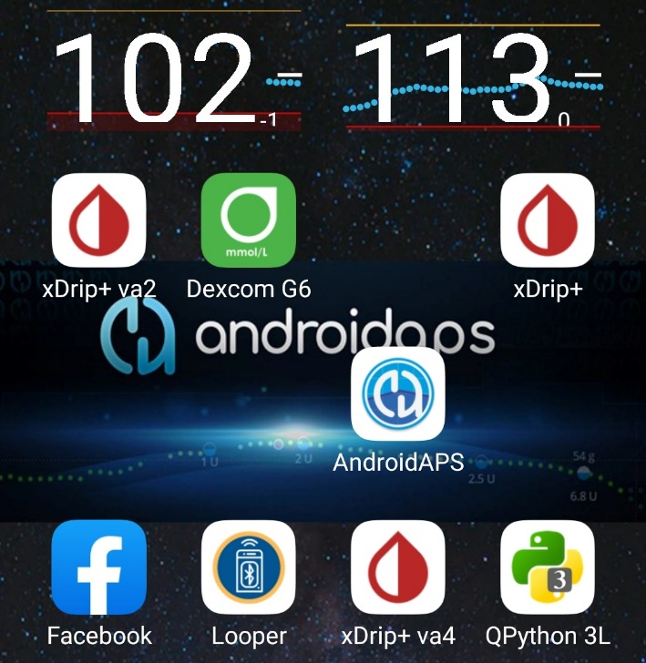
Smartphone main screen with left arm and right arm glucose values
The xDripVar4 back-end is not a necessary part of the set-up. But it allows to draw the xDrip statistics that I like to see regularily on my phone. A rolling 7day and monthly data set allows me to assess quickly how I am doing, and in which times of day improvements should be targeted. That would be not as easy in Nightscout.

Settings in xDrip when using BYODA

xDrip+ xDripVar2 xDripVar4
Hardware Data Source G5/G6 Transm. 640G/Eversense Nightscout Follower
Dexcom Transm. Anubis…….. n/a (enter via BYODA) n/a
Treatments info OFF (coming fr.AAPS) OFF (coming fr.AAPS) Download trtmts. ON
Inter-App ON or OFF OFF or ON always OFF
Cloud Upload ON or OFF OFF or ON always OFF

Settings in xDrip when not using BYODA
xDrip+ xDripVar2 xDripVar4
Hardware Data Source G5/G6 Transm. G5/G6 Transm Nightscout Follower
Dexcom Transm. Anubis. number of regular Tm n/a
Treatments info OFF (coming fr.AAPS) OFF (coming fr.AAPS) Download trtmts. ON
Inter-App ON or OFF OFF or ON always OFF
Cloud Upload ON or OFF OFF or ON always OFF

Additional use of Dexcom receiver

For the left arm (10 day utilization of sensors with new transmitters, as suggested by manufacturer) I usually run the Dexcom Receiver in parallel. This gives me a glucose value purely following manufacturers labelling (instructions).

Extended use of sensors?

Also with new, un-altered transmitters, extended use after 10 days is possible. This requires clipping out the transmitter for about 20 minutes.
However, a „fake“ new sensor start must follow, with a 2 hour block-out of having no glucose values (which is precisely what we want to avoid here).
So I do not do this, but - on my left arm - strictly use as suggested by manufacturer.
I would suggest a second Anubis if for some reason you want to extend sensor life on both arms.

